7.2.8.9 Editors - 3D View - Header - Curve - Edit mode - Segments menu
Edit Mode - Add Menu 1
Subdivide 1
Last Operator Subdivide 1
Number of Cuts 1
Switch Direction 1

Edit Mode - Segments Menu

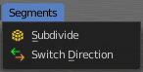
In Edit Mode you will also see a add menu for some object types. The number of objects that you can add is limited to the same object type that you are in edit mode with. You can just add mesh geometry to a mesh geometry. And just curve geometry to curve geometry.

The added objects in edit mode becomes part of the current object geometry.

Subdivide
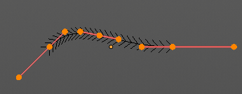
Subdivides the selected curve geometry, and adds more control points.


Last Operator Subdivide

Number of Cuts
Number of subdivision cuts.

Switch Direction
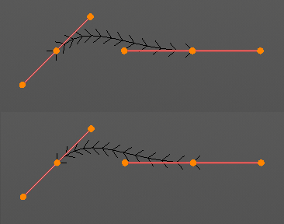
Switches the direction in which the curve is pointing.

